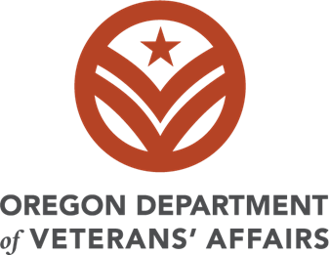

Request for Grant Proposal (RFGP)
2025-2027
Veteran Services Grant
Project Narrative and Budget Narrative Template

Date Issued: Monday, September 8, 2025
Proposals due: Monday, October 13, 2025, 11:59pm PST
Performance Period: January 01, 2026 – June 30, 2027

Submit all required elements listed in Section 6 of the Request for Grant Proposals Solicitation and use the submission link found on ODVA’s webpage.

Section 5: Format & Submission
5.1 Required File Name Format: Organization Acronym_Document Name_VSG_2025
5.2 Required Documents Format & Submission Requirements
- Utilize the Application template. Do not delete section instructions.
- All pages must be standard letter size (8.5” x 11”)
- Project Narrative: Use a 12-point Times New Roman or Calibri font, double line spacing, and 1-inch margins.
- Tables may be in 11-point font single line spacing. Bulleted list recommended for tables.
- Do not use a Table of Contents or divider pages.
- Do not add any graphics and photos.
Section 6: Required Elements
6.2: Project Narrative:
6.2 a. Goal(s): The grant proposal must have at least one goal, or a maximum of three goals. Select (check) which of the following is a goal(s) for the project.
The use of grant funds will help meet the needs of veterans in:
☐ Mental health care or physical health care.
☐ Housing security.
☐ Employment opportunities and employment stability.
☐ Education and training opportunities.
☐ Transportation accessibility and availability.
☐ Promoting veterans’ organizations that provide critical services for veterans within a community, region or on a statewide basis.
☐ Supporting existing programs identified by the ODVA Advisory Committee.

Quarter | Timeline
Q1: Jan 1-March 31, 2026
Q2: April 1-June 30, 2026
Q3: July 1 -September 30, 2026

Q4: October 1-December 31, 2026
Q5: Jan 1-March 31, 2027
Q6: April 1-June 30, 2027

